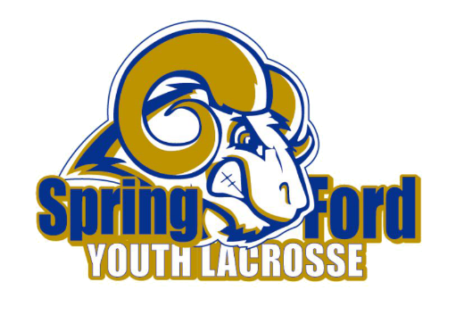
SFYLAX Equipment Rental Request

Player First Name | Player Last Name | Parent Name | Phone Number

Email Address

Equipment Needed | Quantity | Description/Size | Serial Number
Elbow Pads
Gloves
Shoulder Pads
Helmet
Stick (boys only)
Goggles (girls only)
Stick (girls only)

Your signature acknowledges that you are renting the above noted equipment from Spring-Ford Youth Lacrosse. You promise to return the equipment in a timely manner after the season ends, cleaned per the instructions attached. You agree that if equipment is not returned, we will cash and keep your deposit check. If equipment is returned uncleaned or missing pieces, we will cash your deposit check and keep $100 (boys) / $35 (girls) and refund you the difference.
Upon returning, if all equipment rented is accounted for and cleaned, we will tear up your deposit check.

Printed Name:___________________________________ Signature/Date:____________________

--------------------------------------------------------------------------------------------------------------------------------------
Office Use Only

Rental Fee Received: Yes / No / NA (for 1st year players only) Amount: $________ Venmo or Check # _______

Deposit Received Yes / No Amount: $________ Check # _________

